Nutritious meal and snacks served.
I follow USDA food program guidelines.

Here is a sample of my daily menu
Menu Subject to Change
BREAKFAST: French toast
Applesauce
Milk
LUNCH: Tatar Tot Casserole
W/Hamburger & cheese
Peas
Bread
Milk
SNACK: Rice Cakes
Peanut Butter

You can view, download or print my 12 weeks rotation menus from my website. www.daynasdaycare.com

MAIN ROOM
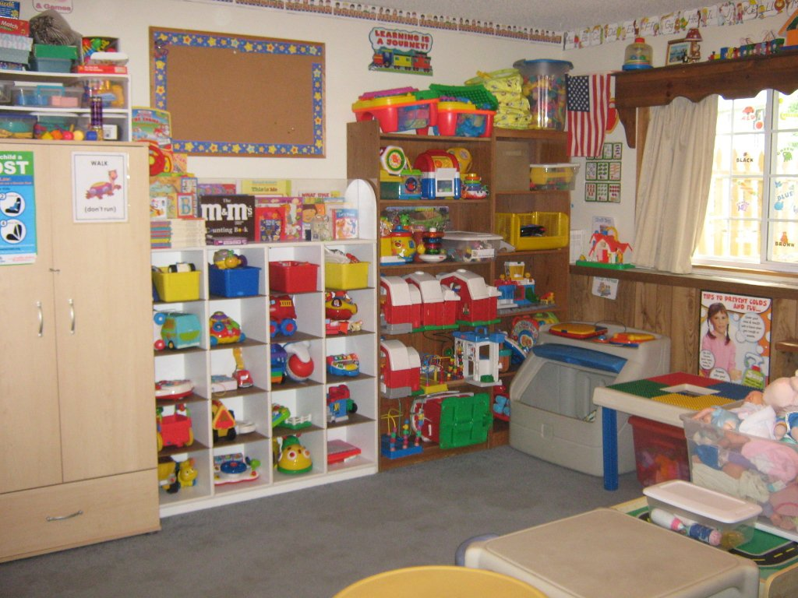
OUTSIDE PLAY AREA
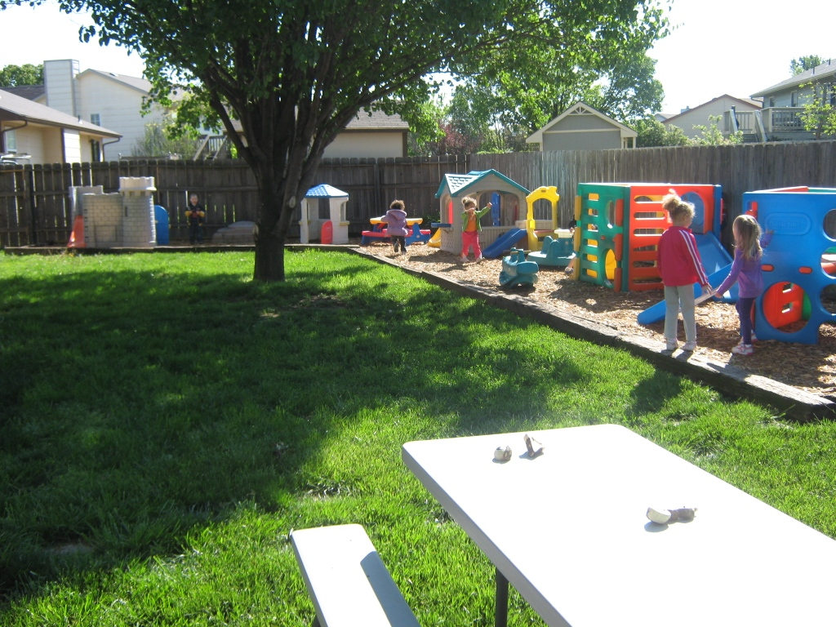
NAP ROOM
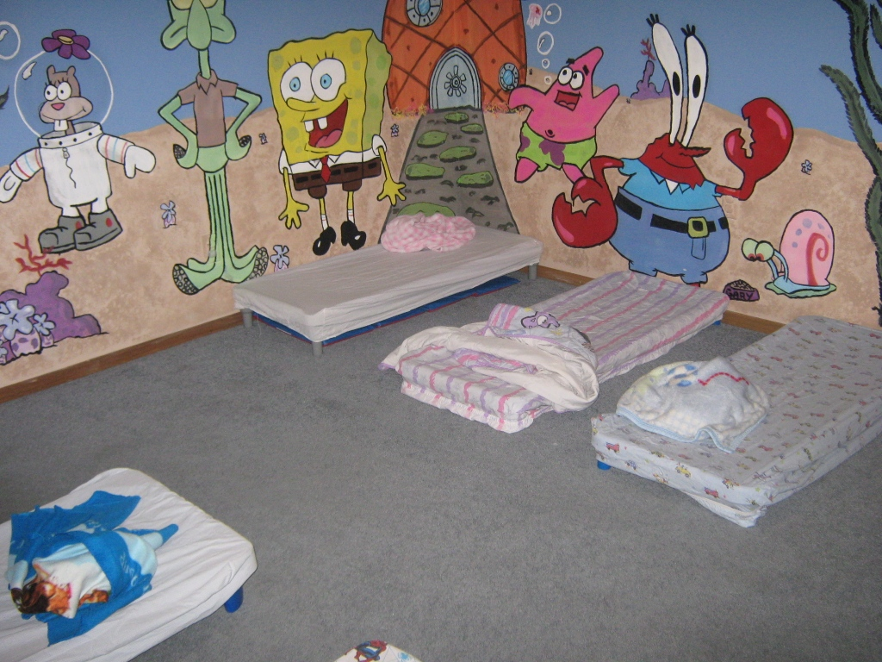


6:30 AM to 5:30 PM
Monday – Friday
Can arrange earlier or later times for a possible additional fee

What My daycare offers

♥LICENSED BY K. D. H. E.
♥ Preschool Weekly Learning Themes , all year around
♥ Close to South Wichita Schools and in Haysville School District
♥ Daily Facebook Updates
♥ Weekly Newsletters
♥ Large Privacy Fenced Back Yard
♥ Reasonable Rates
♥ S.R.S. Subsidy
♥ Hot homemade meals and healthy snacks, USDA food program
♥Loving Care

ABOUT DAYNA & FAMILY
My husband, James and I have been married since 1982.
I am a M.A. (Medical Assistant). I did private duty in home care for over 10 years specializing in Alzheimer’s. Worked years in family practice doctor’s offices.
Was a previous foster parent for 5 years cared for numerous ages and disabilities? Have previous foster children who are adults now with children of their own.
We have a 22 year old special need’s daughter. Who lives at home with us .
We also have a 21-year old son. Who lives at home and attends college majoring in Industrial Engineering.
We also have additional family members, our pets.

CALL FOR YOUR INTERVIEW
316-529-2582
Check out my daycare online below or better yet call for an interview!
Website:
www.daynasdaycare.com
Email:
daynasdaycare@cox.net

Daynas Daycare
301 W. 53rd St. S.
Wichita, KS 67217
316-529-2582 Home
316-734-5519 CELL
316 -529-2582 FAX

